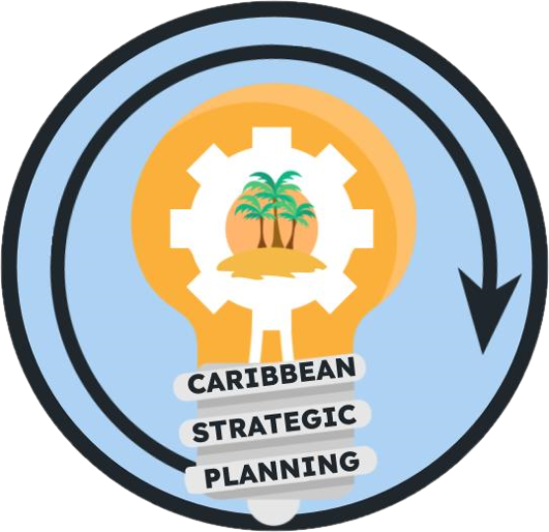Team Charter

Project: Define current communication groups and mechanisms

**Purpose**

Our purpose is to discover and inventory all known communication mechanisms and purposes between the commercial and recreational fishing communities and managers and organizations engaged in fisheries management in the US Caribbean.

**Goals**

Our goals are:

1. Define all organizations in outreach and education on fisheries in the US Caribbean
2. Identify the different sources and mechanisms of communication available
3. Develop flowchart or process diagram of outreach and education methods used by the organizations
4. ~~Identify how or how not agencies interact with communications in current mechanisms~~
5. ~~Provide recommendations on how the effectiveness of communication mechanisms can be assessed or improved~~

Our ideal outcomes are improved interagency and organization management communication to fisheries communities and resources that provide organizations with improved communication mechanisms for the benefit of outreach and education.

The deliverables will be:

1. Flowchart or process diagram of all current communication mechanisms and methods
2. Recommendations on how the effectiveness of communication mechanisms can be improved
3. List of POCs for each communications group including the name, agency, and contact information by island platform
4. Living document outlining the best practices for interacting between agencies, communities, and stakeholder groups
5. Report out presentation to the CSP members

**Team**

* *Lead*: Stephanie Martinez
* *Members*: Sennai Habtes, Sarah Stephenson, Wilson Santiago
* *Stakeholders*: CFMC, CIMAS, DNER/DRNA, DPNR, EBFM TAP, NOAA HQ, NPS, PRSG, QM/CI PSG, SEFSC, SERO, SSC, UPR, USC-A, UVI
* *KSAs*: Alida Ortiz, [Cristina Olán](mailto:cristina.olan.cfmc@gmail.com), USVI liaisons: Mavel Maldonado, Nicole Greaux, Liandry De la Cruz Quiñones, Adyan Rios, DAP chairs PR and USVI Nelson Crespo, Julian Magras, Gerson Martínez.

**Team Process**

* *Meeting day/time*: Thurs 2-3 pm
* *Meeting frequency*: Every 4 weeks
* *Decision-making procedures*: Group consensus
* *Team communication*: Google Meet for standing or any ad-hoc meetings, group emails for routine communications between meetings, and comments in working drafts placed in team google drive folder

**Team Norms**

* *Values*:
  + Integrity, reproducibility, transparency, and communication of data
  + Innovation through adaptive management and continuous improvement
  + Respect and trust in data and partnerships
  + Diversity and inclusivity of data sources, data input, communities, and stakeholder ideas
  + Collaboration and cooperation in the collection and dissemination of data
* *Agreements*: The Team agrees to work in an environment of mutual respect where all Team Members will be given an opportunity and encouraged to present ideas and viewpoints. Hand raising will not be needed during google meets as long as team members do not talk over each other.

**Supporting Resources**

* *Google Drive folder*: [Working Groups](https://drive.google.com/drive/folders/1GR0WWtq_eOGT89s0n8p1imwZ1ntcnczN)
* *Project facilitation*: Rachel Banton (rachel.banton@noaa.gov)
* *Process facilitation*: Richard Maclin, Vivian Matter (vivian.matter@noaa.gov), Jenny Suter (jenny.suter@noaa.gov)

**Metrics**

Success will be measured by a document that identifies and describes the current communicators and mechanisms